**CARRY-A-WAY**

**Sprint 1 demo**

Frontend document

**Developers:**Namita  
Sai Bhavana Nammi

INTERFACE

The idea of Carry-A-way is to provide users with a cheap, convenient, step-by-step tracking and messaging enabled shipping facility for their check in luggage/item/sports/music kit etc. through courier service of their choice and get it picked/delivered at their origin/destination doorstep. All in just few clicks.

Carry-A-way is a web application developed using Go and Angular which allows users to travel hassle free without a worry of carrying bulky luggage/items and paying heavy charges to airlines.

* This document refers to the frontend development work that was performed and completed in the sprint 1 (20th January 2022 to 4th February 2022).
* The development work is demonstrated in further pages with the help of code snippets and working screenshots.

Table of Contents

User Stories Worked On 4

User story #1 4

User story #2 5

# User Stories Worked On

User story #1 Designing and implementing Homepage.

* **Description:** As a User, I should be able to land on the home page and navigate/toggle between different menus.

**Acceptance Criteria:** User should be able to view the details of the application and toggle between below mentioned menus.

* Home landing page
* How It Works
* Sign In
* Pricing
* Home landing page
* How It Works
* Sign In
* Pricing

User should be able to view the details of the application and toggle between below mentioned menus

* Home landing page
* How It Works
* Sign In
* Pricing
* The API should return the values in the expected JSON format.

Fig 1.1

Fig 1.2

Fig 1.3

**Fig 1.1, Fig 1.2, Fig 1.3:** This image shows the Homepage of the Carry-A-Way website.

Fig 2

**Fig 2:** This image shows navigation from Homepage to Login page.

Fig 3

**Fig 3:** This image shows the navigation from Homepage to the Pricing page.

User story #2 Designing “How it works” page.

* **Description:** As a User, I should be able to land on the “How it works” page.
* **Acceptance Criteria:**
* User should be able to view the details of the page.

Fig 4.1

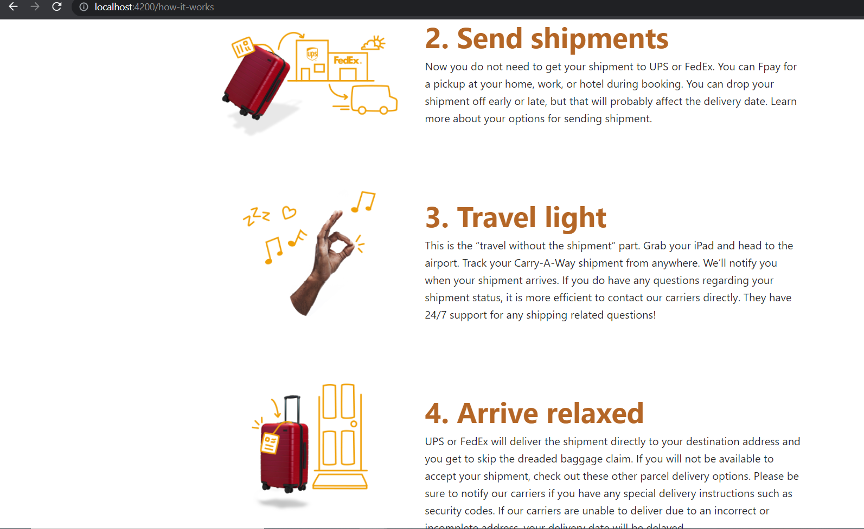  
Fig 4.2

**Fig 4.1, Fig 4.2:** This image shows the How it works page.